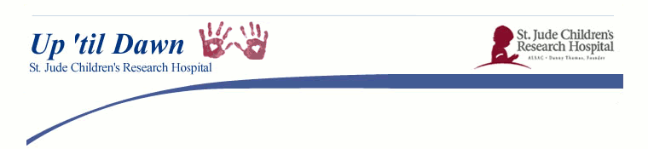

|  |
| --- |
| **spacer** |

**"One Night. One Cause. Our Campus"**

**November 6th from 5pm-1am in Burney!**

**Q: What the heck is Up 'til Dawn?**

Up 'til Dawn is a student led organization that raises funds & awareness for St. Jude Children's Research Hospital. We have ONE big fundraising event all year, making us a low commitment organization that anyone can participate in. It costs over $1.4 million each day to keep the doors of St. Jude open, so our yearly donation is extremely important. Kids are treated at St. Jude regardless of inability to pay.

**Q: What exactly will I be doing on November 6th?**

Come ready to address pre-written letters to friends & family. We will be raffling off a Nintendo Wii for participants who address over 35 letters. A $5 donation fee for your T-SHIRT will be collected at the door from each participant. After turning in your letters, join us to celebrate the lives of children and your dedication. There will be free food, entertainment, a surf simulator, inflatable twister, bungee runs, sumo suits, games, PRIZES, & more!! Tell your friends!

**Q: What you need to bring on November 6th:**

- Names & addresses of friends & family (phonebooks are not allowed)

* Attached is the Finding Names Fast form to help you think of friends & family!
* (Think High School Graduation Lists)

- Address Labels (optional but recommended)

* Preprint out the names & addresses on your own OR log onto uncw.edu/uptildawn , click on the Events link & find out how we can PRINT YOUR LABELS FOR YOU!
* Preprint out labels for the “Student Section” of your letter also. We can do this for you as well if you email us the form (uncw.edu/uptildawn). Student section information contains: your Name, Address, Email or Phone, & Team Name
* **Please note: if you use PRINTED ADDRESS LABELS, it’s important that you decorate your envelope in some way or add your name to the St. Jude Return Address so that your friends & family don’t mistake your letter for Junk Mail.**

- A team of cheerful smiling people & a little bit of your time.

- A willingness to help with the fight against childhood cancer!

**DON’T BRING: STAMPS! THEY ARE PROVIDED!**

(Remember the letters are prewritten, so all you have to fill out is the senders’ name, address, your name, your address, email, & team name)

**Q: Does the Letter Writing Event count as community service?**

Yes! Up ‘til Dawn is a great way to gain volunteer hours & leadership skills all while helping a worthwhile cause. Unite with other students as you raise money for the kids at St. Jude Children’s Research Hospital.